Basics

Linux is a family of freely available operating systems that are developed as a distribution. It has been the operating system of choice for most colleges and businesses due to its robustness and its extremely low cost of acquisition. Linux runs everything including your phone. If you have an iPhone, it runs Unix which is the predecessor of Linux and is essentially the same thing.

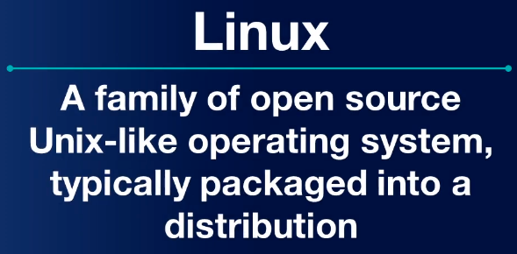
You may have heard of popular Linux distributions such as Ubuntu, Debian, and Fedora, but there are hundreds, if not thousands of others currently in development. To determine the distribution you’re using execute the following command: cat /etc/os-release

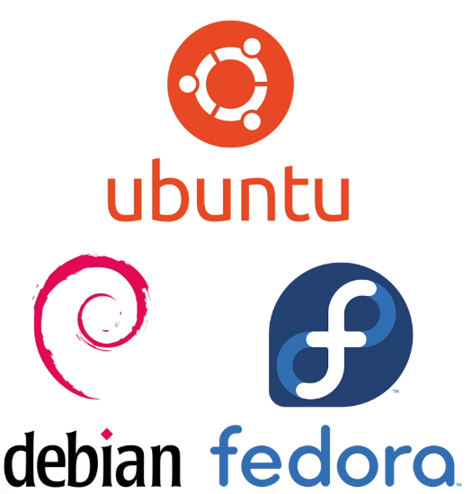

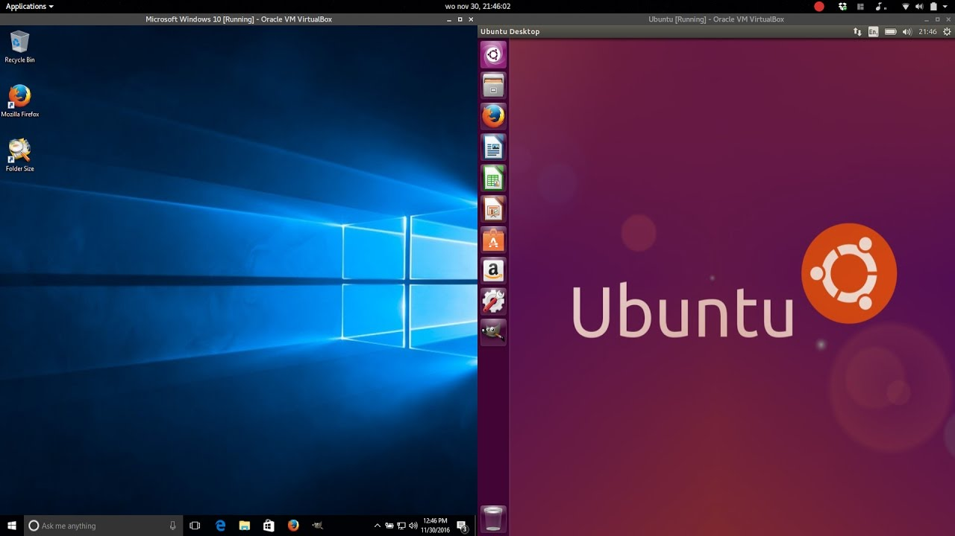
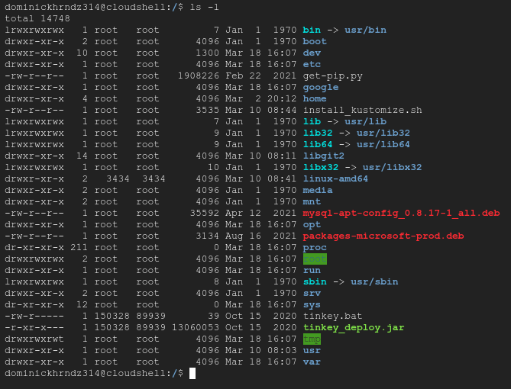
The popularity of Linux is mainly due to it being Open Source Software, which means its free to download, modify, and redistribute. Some Linux distributions, or distros, are similar to Windows 10 as they offer a GUI (Graphic User Interface). However, many distros will ONLY include a terminal to run your command line.

If you are new to Linux, it is highly advised that your either install WSL into Vscode or you deploy your own virtual machine running Ubuntu Linux. If you are on Mac, you can simply use your terminal to run Linux commands.
The core of any Linux distro is the Kernel. The kernel is a low-level computer program that serves as a bridge between the user and computer resources. Typically, Linux distros are available for download and can be burned to a CD or USB, then installed onto your computer. If you’re using AWS of GCP, compute instances can run Linux directly.

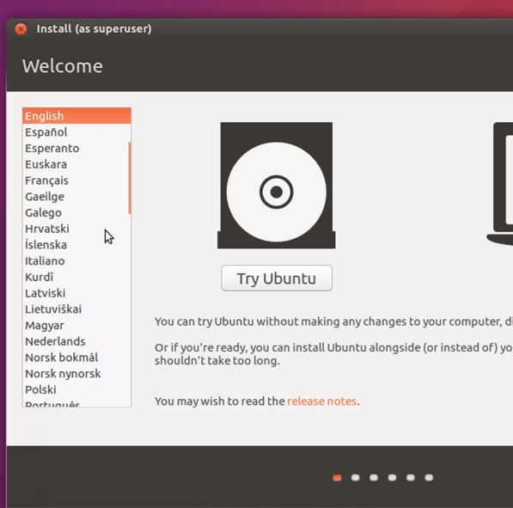
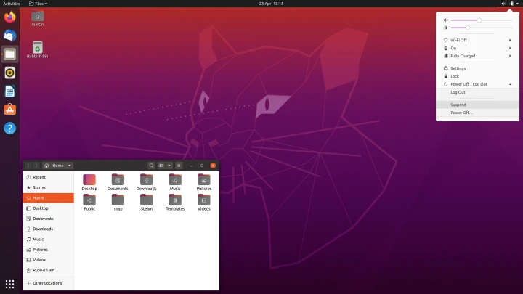
If you would like to install Linux on your Windows machine, you will need to follow the instruction in this link: https://www.lifewire.com/install-ubuntu-linux-windows-10-steps-2202108
Doing so will allow you to run Linux with a desktop similar to what you would expect from Windows.

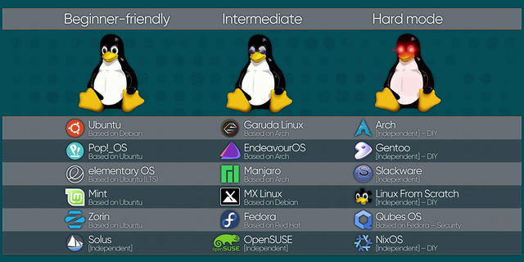
As mentioned everything in the world runs on some form of Linux. Phones, TVs, smart devices, vehicles, web site, etc. Some Linux distributions are specific to the development of these consumer products. For example a distro like Kali Linux is specifically built with a suite of cyber security tools used by pen-testers and cyber security analysts.
If you’re installing Linux on a new laptop or your installing on a virtual machine from your existing computer, you have to ensure the following requirements:

